Day 29 – NAT + Troubleshooting (Advanced Scenario Day)
Today is not “practice”. Today is breaking + fixing like a real support engineer.

🔧 Task 1: Create a Broken NAT Scenario
Setup:
- VM in NAT mode
- Confirm internet works:
ping google.com
Now break it intentionally:
👉 Remove default route:
sudo ip route del default
Test:
ping 8.8.8.8
❌ It should fail
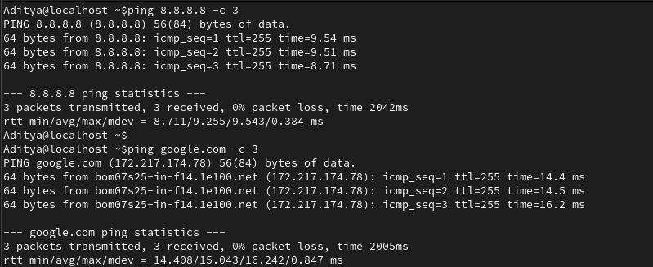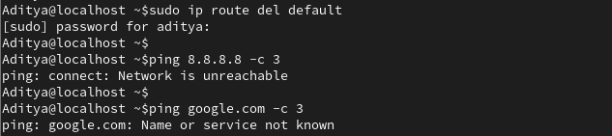
🔍 Task 2: Diagnose Like a Pro
Run these in order:
ip a
ip route
ping 8.8.8.8
Ask yourself:
- Do I have IP? ✅
- Do I have gateway? ❌ (this is the issue)
👉 You must identify problem BEFORE fixing
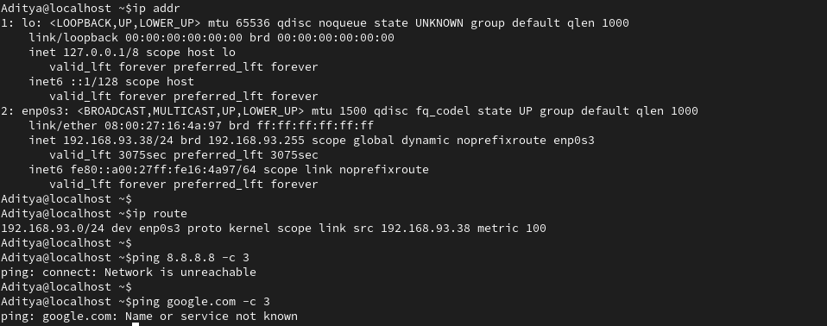

🛠 Task 3: Fix It
Add route back:
sudo ip route add default via 192.168.0.1 dev enp0s3
Test:
ping 8.8.8.8
ping google.com
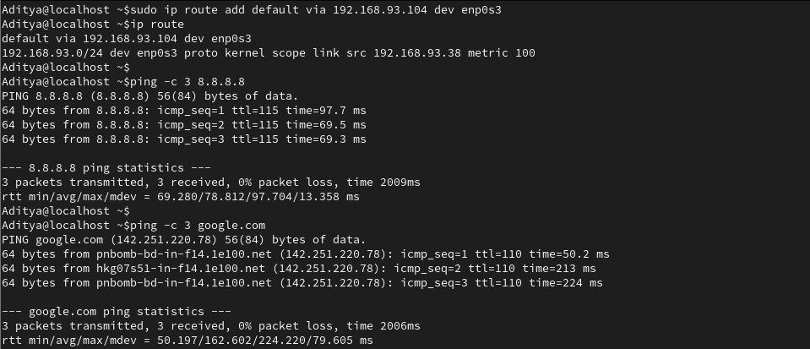

🔥 Task 4: Second Failure Scenario (DNS Break)
Break DNS:
sudo vi /etc/resolv.conf
Change to:
nameserver 1.2.3.4
(or delete everything)

Test:
ping google.com ❌ fails
ping 8.8.8.8 ✅ works
👉 This is classic interview question
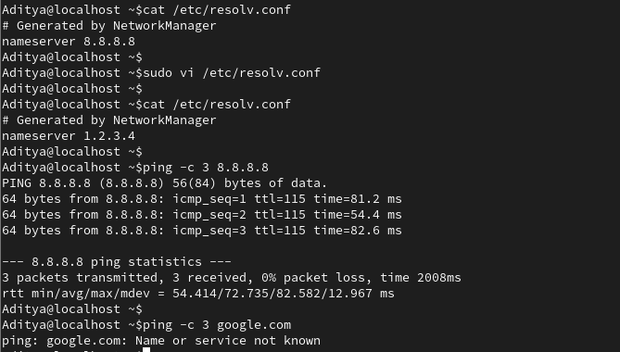

🧠 Task 5: Write Real Troubleshooting Flow (MOST IMPORTANT)
Write this in your notebook:
Internet Not Working – Debug Flow
- ip a → Check IP
- ip route → Check gateway
- ping 8.8.8.8 → Check internet
- ping google.com → Check DNS
- /etc/resolv.conf → Fix DNS

🎯 Expected Output (Non-Negotiable)
You must have:
- ✔ 2 broken scenarios created
- ✔ Both fixed by YOU (not guessing)
- ✔ Clear troubleshooting steps written
- ✔ Understanding of:
  - NAT vs DNS failure
  - IP vs Gateway vs DNS

📓 Day 29: NAT + Troubleshooting (Advanced Scenario)
🛠️ Part 1: The Golden Troubleshooting Flow
When "the internet is down," always follow this outside-in logic:
- ip a: Do I even have an IP address? (Layer 1-3)
- ip route: Do I have a "Default Gateway" (0.0.0.0/0)? (Routing)
- ping <Gateway_IP>: Can I talk to my local router/hotspot? (Local Connectivity)
- ping 8.8.8.8: Can I reach the outside world via IP? (Internet/WAN)
- ping google.com: Can I translate names to IPs? (DNS)

🛠️ Part 2: The Two Failure Scenarios
Scenario | Symptom | Diagnostic Command | The Fix
Missing Route | ping 8.8.8.8 fails with Network is unreachable. | ip route (Table is empty or missing default). | sudo ip route add default via <IP> dev <Interface>
DNS Failure | ping 8.8.8.8 WORKS, but ping google.com FAILS. | cat /etc/resolv.conf (Check nameserver). | Edit /etc/resolv.conf to add nameserver 8.8.8.8

💡 Key Lessons Learned Today
- NAT vs. Bridged: NAT puts the VM in a private bubble; Bridged puts it on the same network as the host (e.g., your phone hotspot).
- Gateways must be reachable: A gateway IP must belong to the same subnet as your VM's IP, otherwise, the system will return Invalid gateway.
- DNS is the "Phonebook": You can have a perfect internet connection, but if your phonebook (resolv.conf) is empty or wrong, you cannot browse by name.

